Content | Page(s)
- EasyPHP 1.8 | 2-3
- TortoiseCVS | 4-5
- PuTTY | 6
- Set up a user account in sourceforge.net | 7
- Putty Configuration | 8-14
- Configure Account | 15-20
- Ensure programs are running | 21-22
- TortoiseCVS Configuration | 23-25
- TortoiseSVN | 26-28
- Subscribe to Mailing List (Optional) | 29-21

*** NOTE:

If you used TortoiseSVN, you may not need to download TortoiseCVS and Putty as you can type in the URL directly.

If you used TortoiseCVS, you may not need to download TortoiseSVN but you need to download putty and follow the rest of the instruction given on the document.

- EasyPHP 1.8

Please download these programs before working on the conference system.

  - http://www.easyphp.org/

    - Main Menu>Downloads link on the left side of the web page.
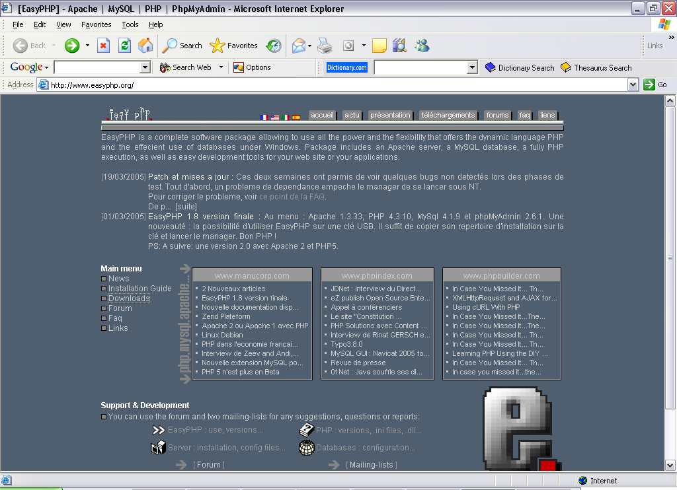

    - Download the most current version.

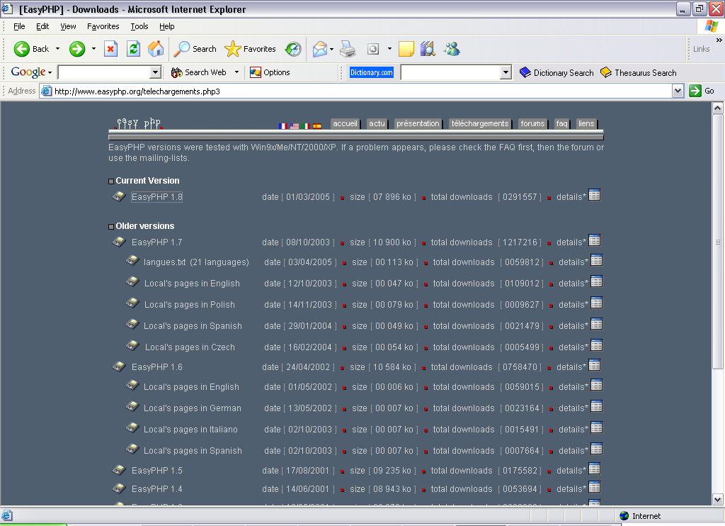

    - Select a mirror closest to your current location for faster download speed and click the link on the “Download” column.
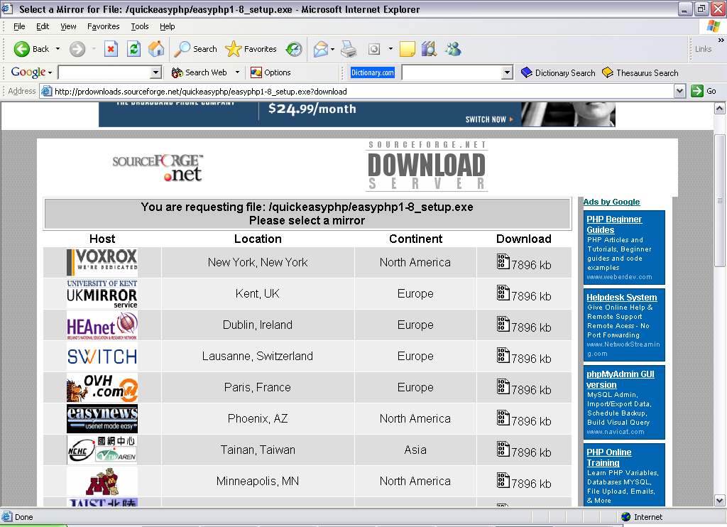

  - TortoiseCVS

Go to http://www.tortoisecvs.org/

    - Click on Downloads
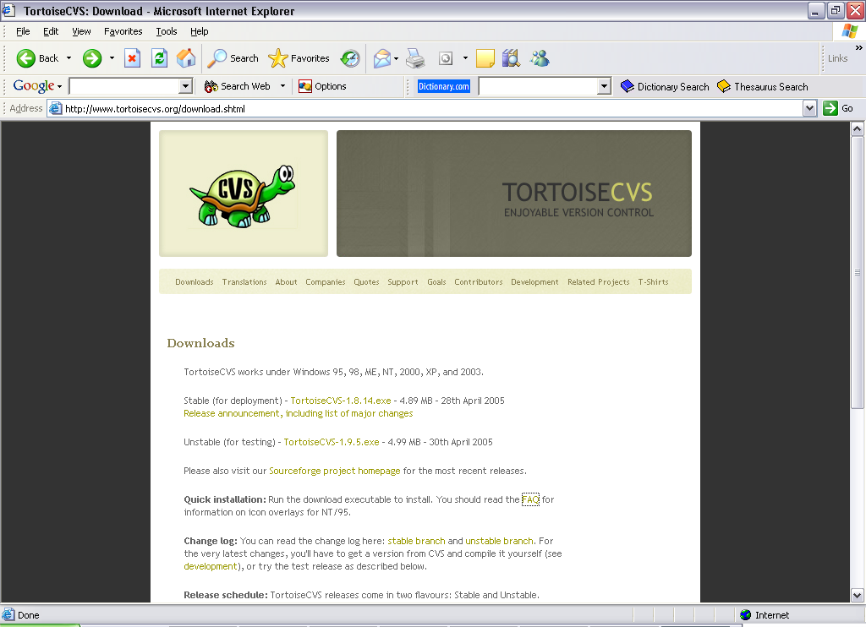

    - Select the program version which is categorized “Stable (for
deployment)”.
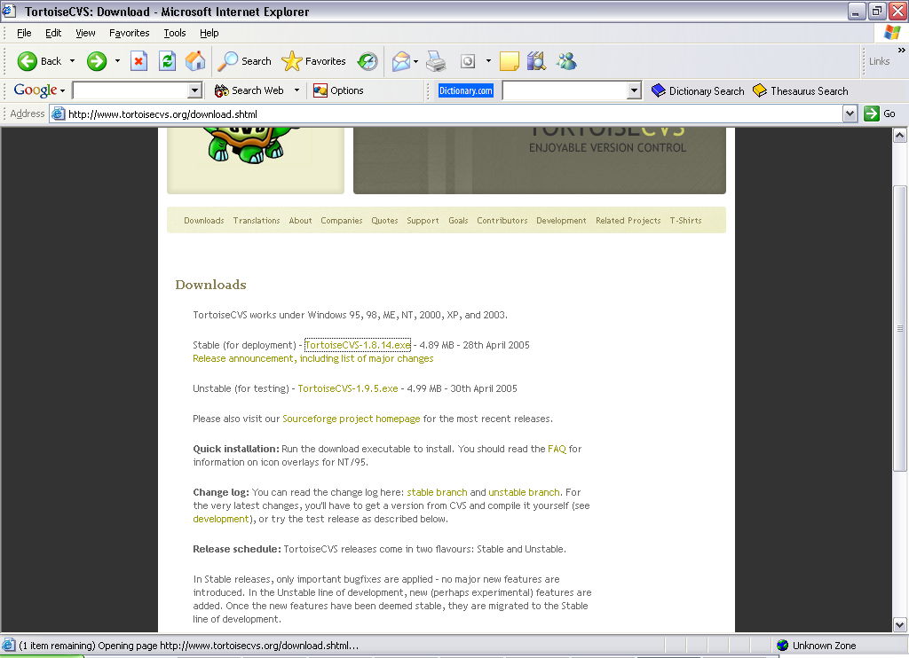

    - Select a mirror closest to your current location for faster download
speed and click the link on the “Download” column.
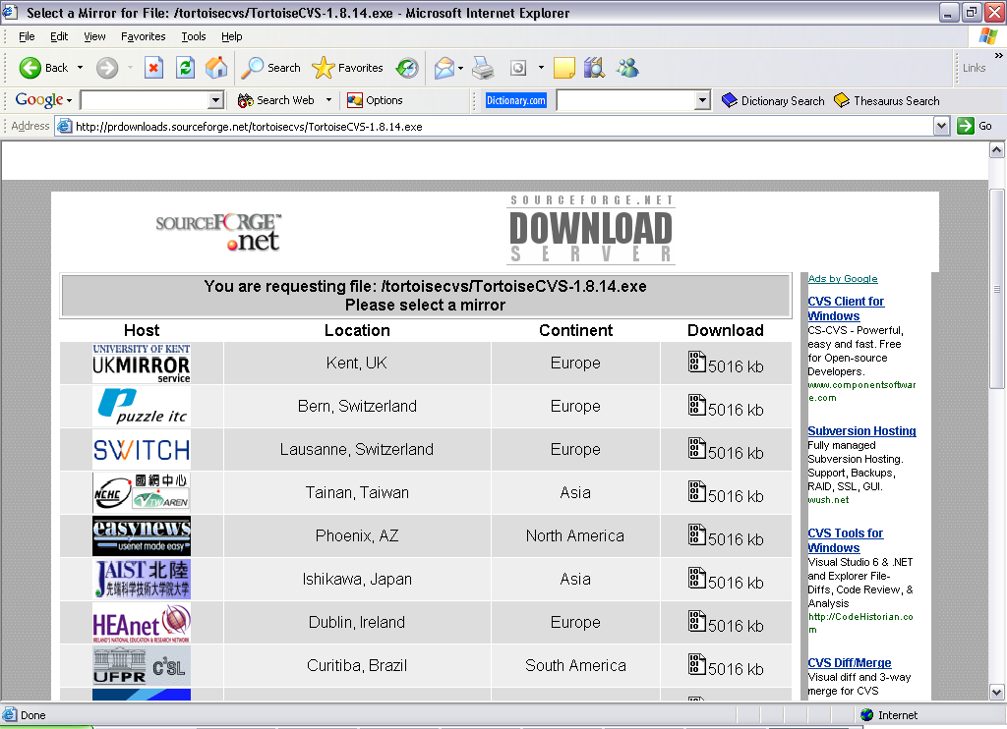

    - Down
    - Load will begin and click “Save”.

  - Putty
http://www.chiark.greenend.org.uk/~sgtatham/putty/download.html

    - Scroll down the page and download the installer according to your Operating System. For example, users using Windows XP will have to download installer as shown within the blue box.
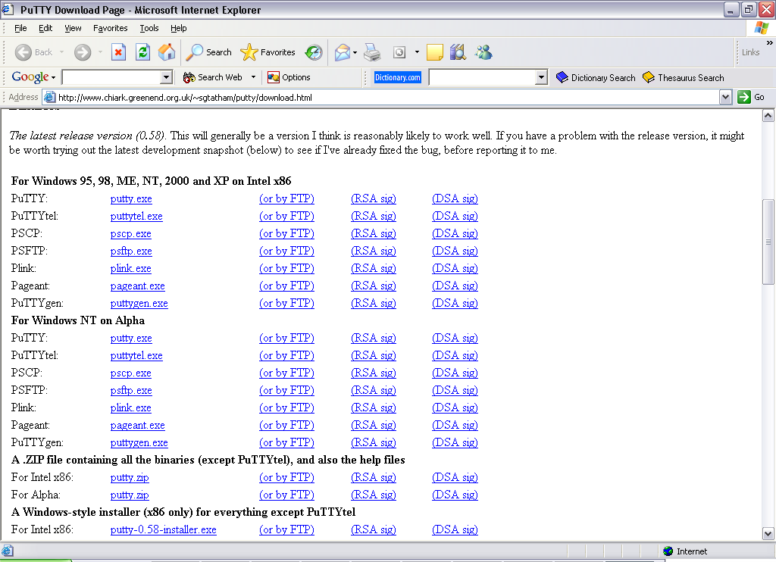

    - Download will begin and click “Save”.

  - Install all downloaded programs and follow instructions given to complete installation

- Set up a user account

  - Create a user account on http://sourceforge.net

  - Click on “New User via SSL” on the left navigation and follow instructions accordingly.

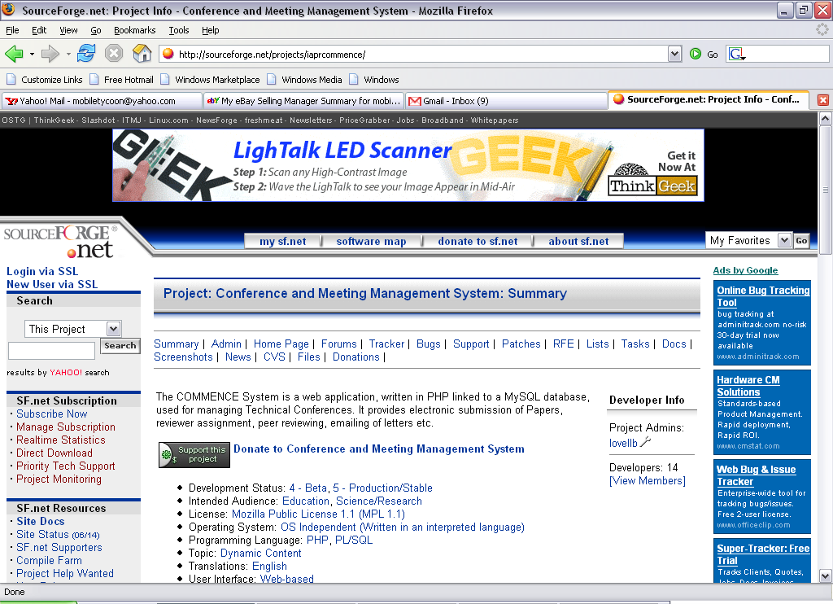

  - Inform the administrator about your new account and he/she will register you as a developer for the project.

PuTTY Configuration

Once PuTTY has been installed successfully onto your system, go to

  - Start>Programs>PuTTY> PuTTYgen

  - This will be the interface that you will see upon clicking on
PuTTYgen.

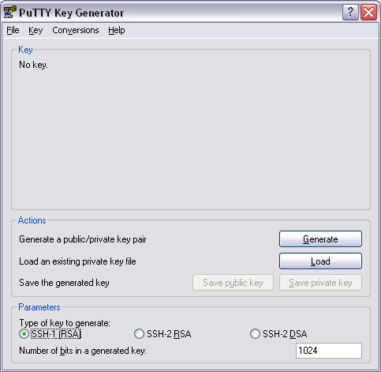

  - Select “SSH-1(RSA)” which can be found at the bottom of the dialog box shown above, 3.2.

  - Click on the “Generate” button.

  - Randomly move your mouse cursor within the area of the blue box shown.

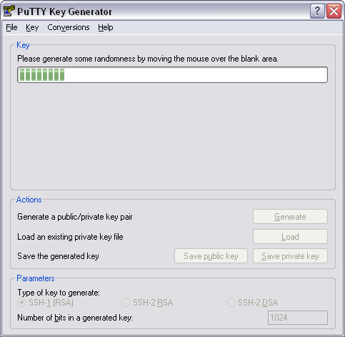

  - Click on “save private key”, we recommend you saving it in a folder because we will need to refer to this private key when using Pageant. You need not save the public key because by clicking the “save private key” button, it helps to save both public and private key. Do not exit PuTTYgen yet.

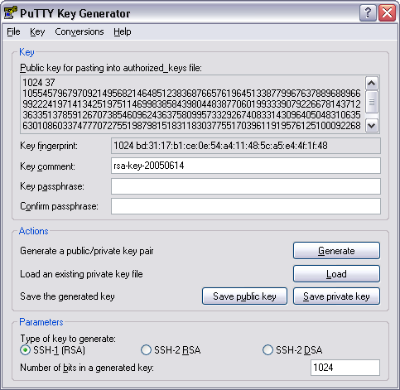

  - Open Pageant program and this will be the interface that you will see.

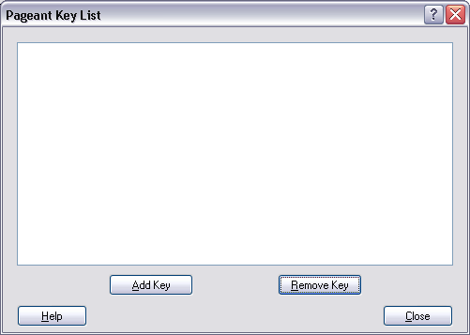

  - Click on “Add Key” button and locate where you have just saved your private key. It has an extension of .ppk, E.g. Private_key.ppk. Select the private key and click open on the dialog box shown below.

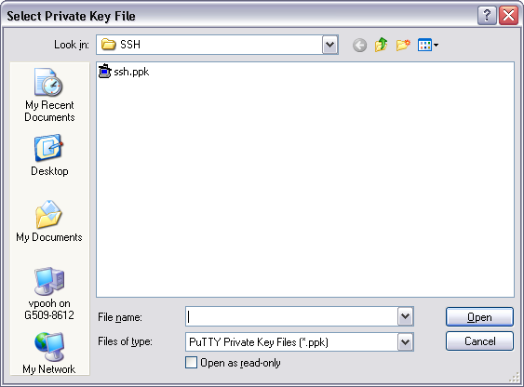

  - You can now exit Pageant and you will notice that Pageant can be seen on your taskbar.

  - Go to Start>Programs>PuTTY>PuTTY

  - Copy everything seen on this interface to your own PuTTY and click the “save” button to save your session.

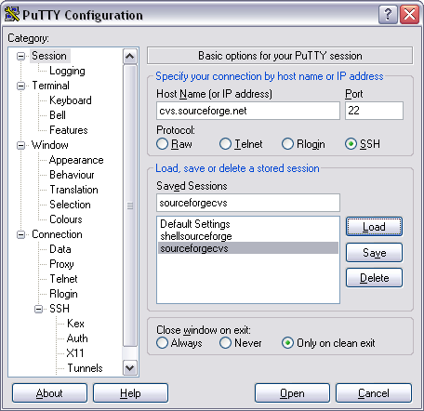

  - Please copy everything again from the interface below and click “save”, as we are going to use this session to verify if everything is working accordingly later on.

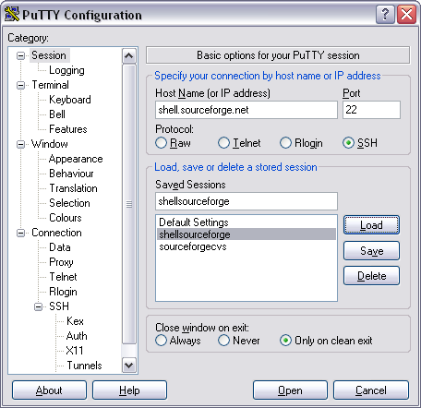

Configure Account

Do this only after your administrator has added you to the Developers’ list and you have also configured PuTTY successfully.

  - Login to http://sourceforge.net/projects/iaprcommence/

  - After you login, you will be viewing this interface.

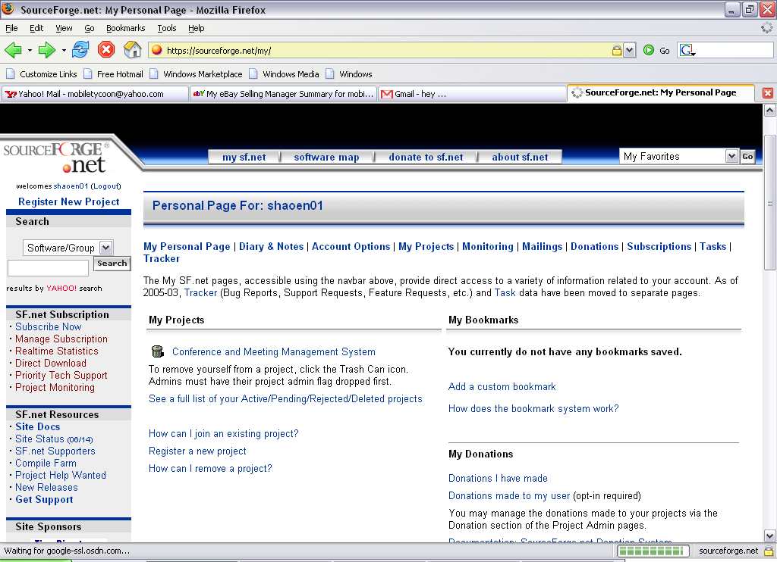

  - Click on “Account Options” and scroll down until you see a similar interface shown below.

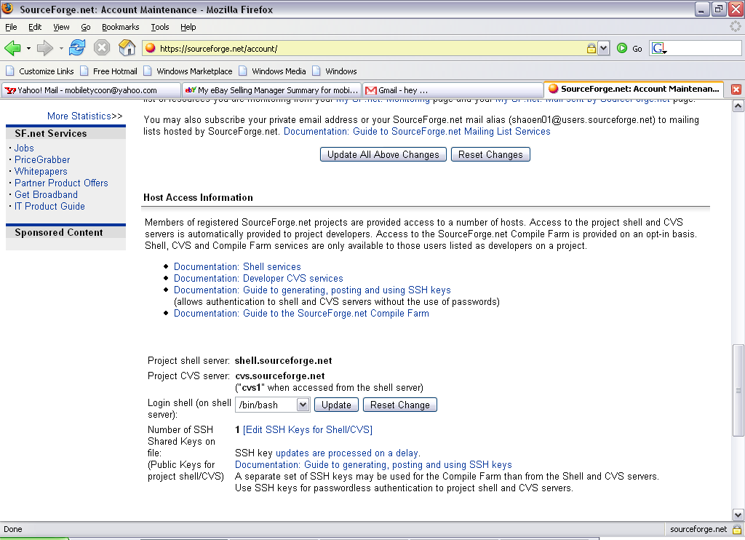

  - Click on “[Edit SSH Keys for Shell/CVS]” to add your public key. Notice that you have 0 SSH keys at the moment.

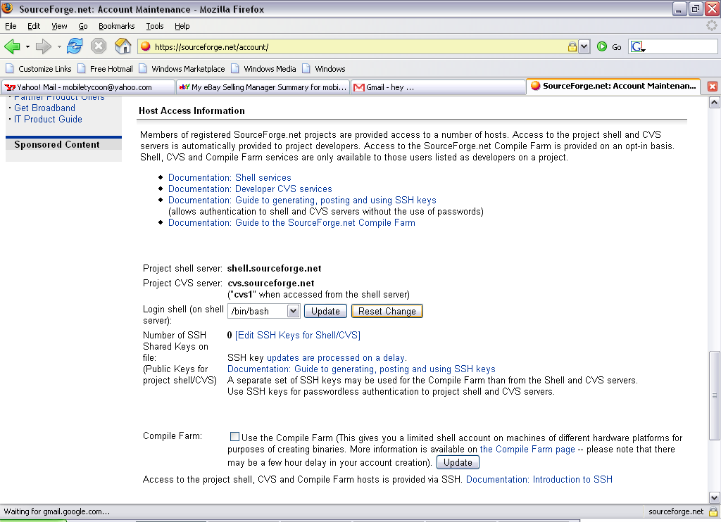

  - Copy the public key from PuTTYgen, just highlight all the contents in the box as shown below.

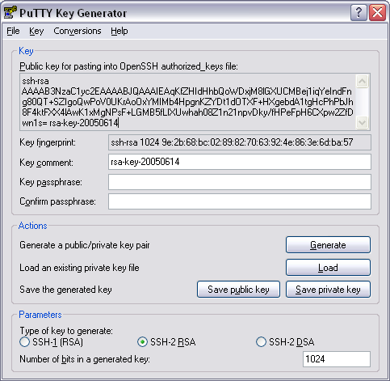

  - After you paste the public key in the blue box below, the public key will be aligned in a straight line. Remember to click the “Update” button.

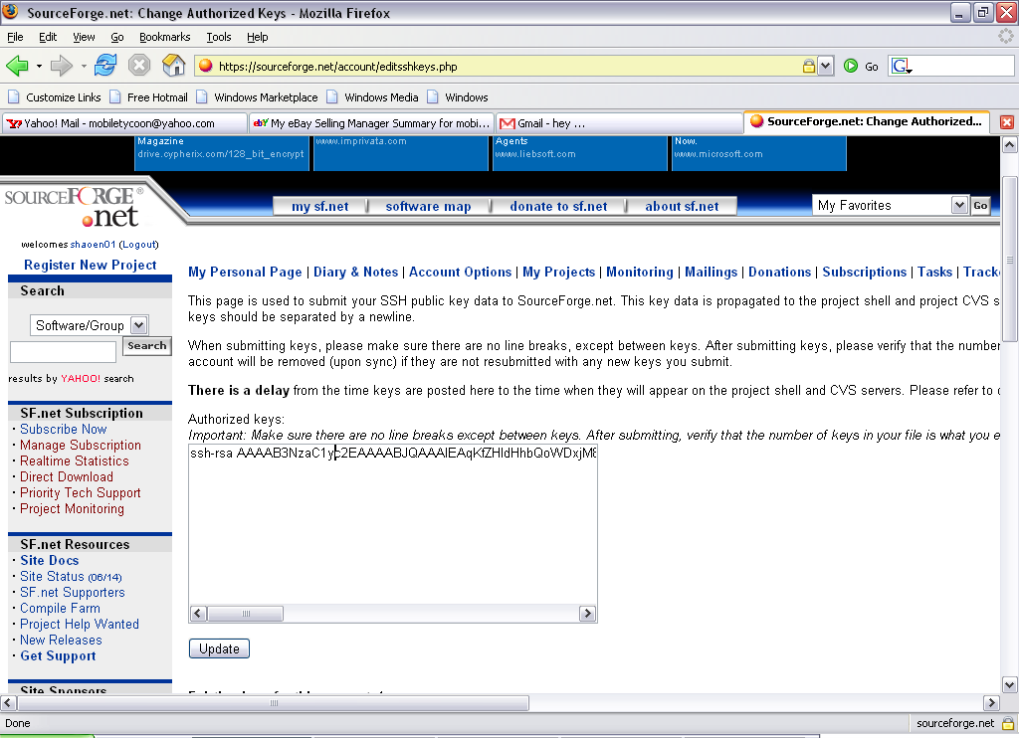

  - After you have updated, scroll down and make sure that you see you have at least 1 SSH key.

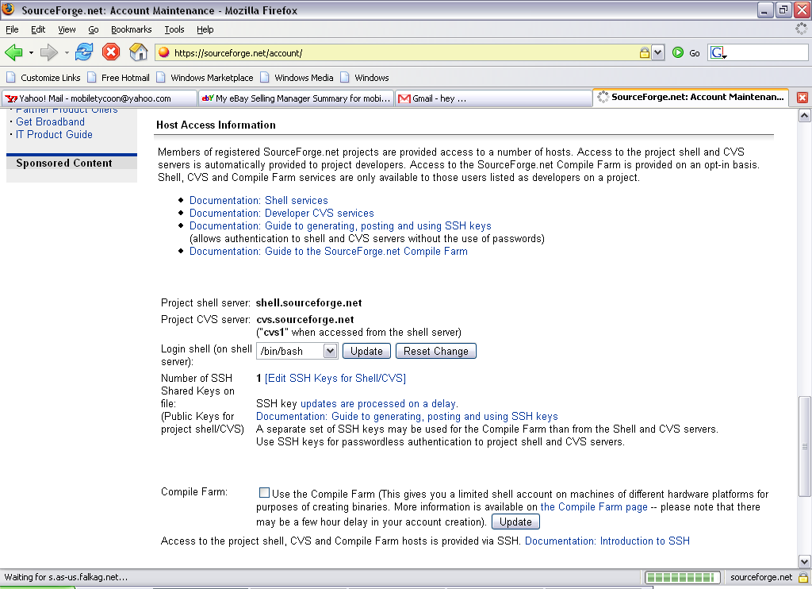

  - It may take an estimated 10 minutes to an hour before your SSH key will be distributed to all the servers in the server farm.

  - You may now exit PuTTYgen.

Ensure programs are running

We shall now check if you have successfully configured the PuTTY and set up your account.

  - Do you recall that you have saved a session called “shellsourceforge” earlier at step 3.12? We shall now use that to check if we have done everything correctly.

  - Go to Start>Programs>PuTTY

  - Select “shellsourceforge” and click “Open”.

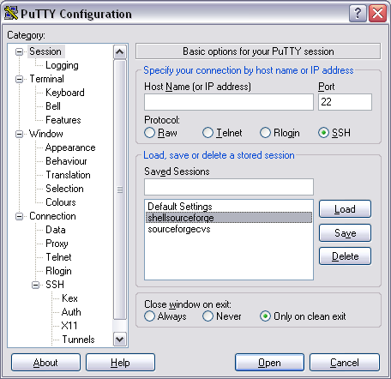

  - Type your login id of the account that you have created earlier at step 4 and click the “Enter” key.

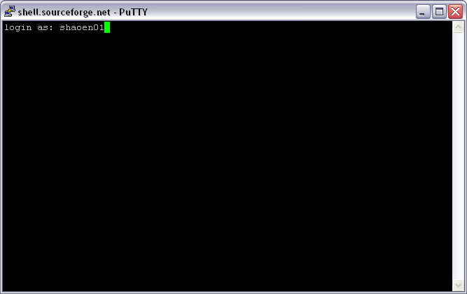

  - When you see this interface below, you have successfully set up your account and configured your PuTTY. If you do not see a similar interface, please re-do steps 2-4, check if you have downloaded and installed all the necessary programs in step 1.
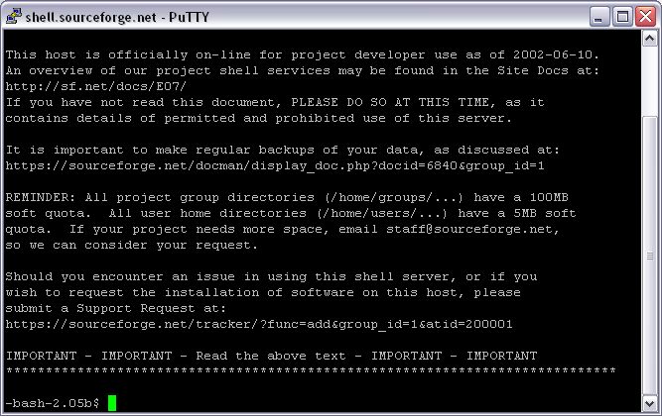

TortoiseCVS Configuration

Please make sure you have successfully installed TortoiseCVS and follow steps 1-5 before you proceed.

  - Right-click on your desktop and select “CVS Checkout …”

  - Please copy everything shown below but change “shaoen01” to your own username/login id. And click on the “Ok” button.

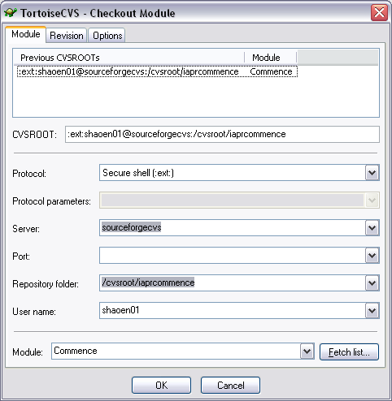

  - If you have done it right, TortoiseCVS will start downloading the Commence Module now. If it is not downloading or display any error message, please check that everything is correct because a missing or an additional letter/symbol makes a difference.

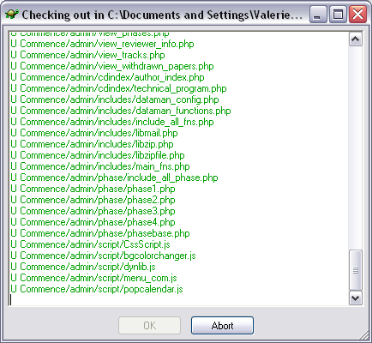

  - Click on “Ok” and you have successfully downloaded all the files you need after you see the message “Success, CVS operation completed”. By default, the Commence folder will be downloaded onto your desktop.

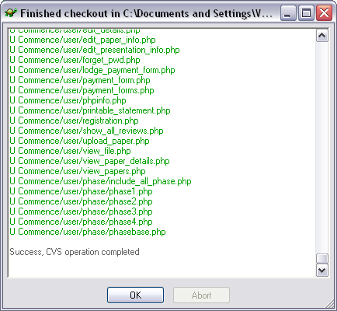

7. Tortoise SVN

7.1 Go to http://www.tortoisesvn.org/

  - Click on the download link show below:
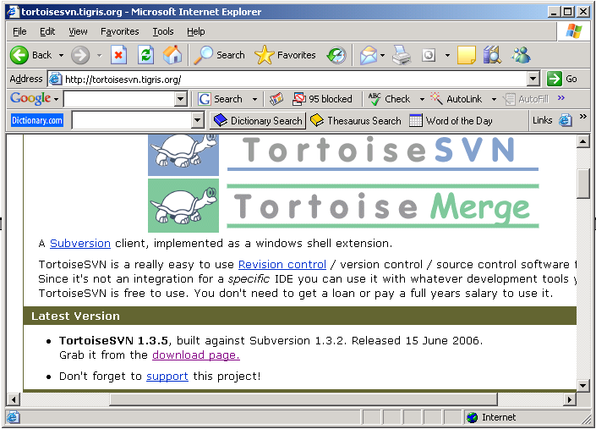

  - Scroll down and look our for Download Applications 32-Bit and click on
TortoiseSVN-1.3.5.6804-svn-1.3.2.msi Installer

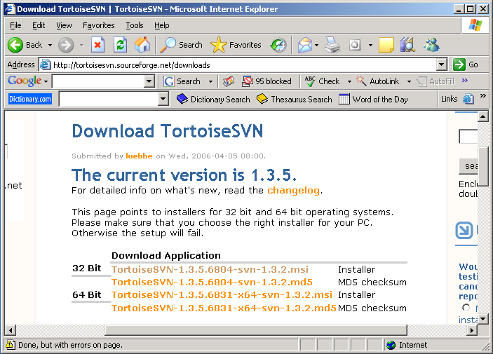

7.4 Select a mirror closest to your current location for faster download
speed and click the link on the “Download” column.

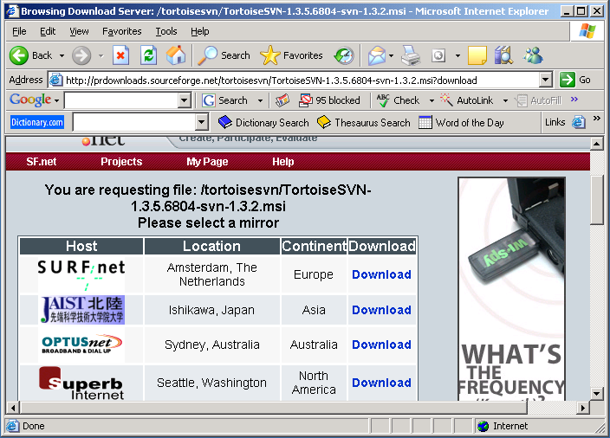

7.5 Load will begin and click “Save”.

7.6 After downloading the TortoiseSVN file, run the program.

7.7 Once you had run the program, update SVN Checkout on the main desktop.

7.8 In order to update the SVN Checkout, right click the mouse and click on SVN Checkout.

7.9 Once done you will see this box appear shown below. Type the URL of Repository as stated below:

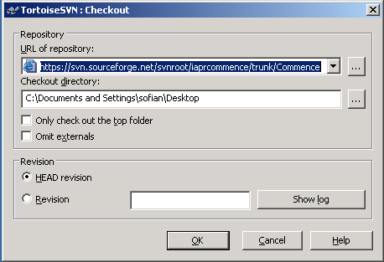

7.10 Click OK

7.11 SVN will update and the program will automatically download the program on your desktop.

7.12 Once completed, cut the file that has already been downloaded to the root directory that is given to you in your httpd.conf file which is www.

Subscribe to Mailing List (Optional)

Please do this only after the administrator has added you to the developers’ list.

  - Login to https://sourceforge.net/account/login.php

  - Click on the project you wish to subscribe to the mailing list. You can find a list of projects shown below in the interface.

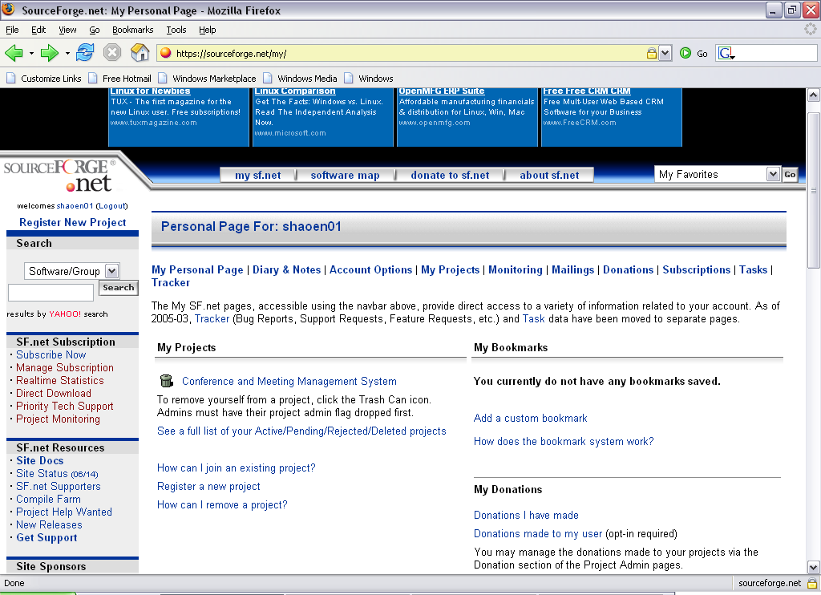

  - Click on your project link>Lists>Subscribe/Unsubscribe/Preferences.

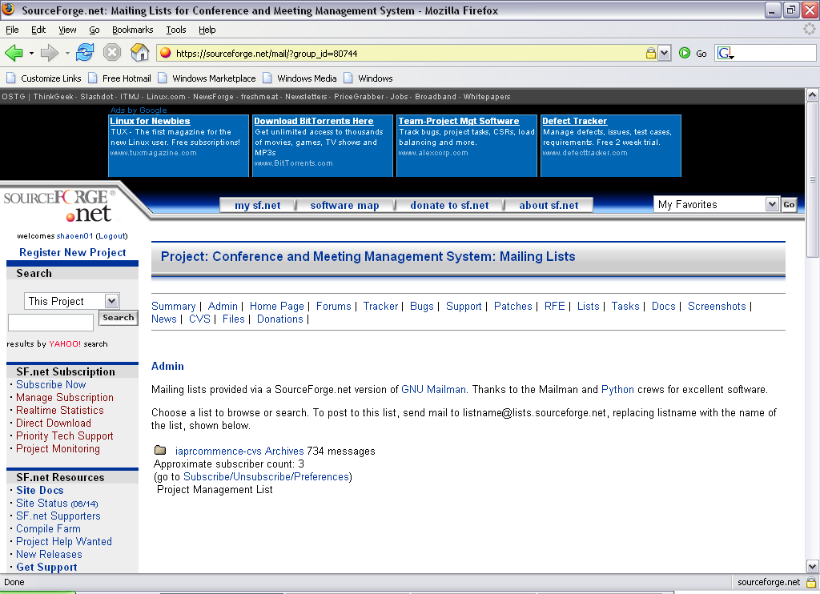

  - After which, you will be directed to the interface shown below. Fill in all the fields, click the “Subscribe” button and check your email for further instructions.

